**Project Design Phase-II**

**Technology Stack (Architecture & Stack)**

|  |  |
| --- | --- |
| 📅 Date | 30JUNE 2025 |
| 👥 Team ID | LTVIP2025TMID31307 |
| 👥 Team Size | 4 |
| 👑 Team Leader | K Veera Venkkateshh |
| 👤 Team Members | - G Satya Veera Durga Prasad  - K Manikanta  - K Vikhitha |
| 📌 Project Name | Public Transport Management System |

**Technical Architecture**

The **CRM Application For Public Transport Management System** is designed using Salesforce architecture components to deliver a scalable, secure, and user-friendly platform for managing employees, buses, daily trips, and related transport assets. A high-level architecture diagram illustrates the interaction between the user interface, Salesforce automation, data storage, and reporting components tailored for public transport operations.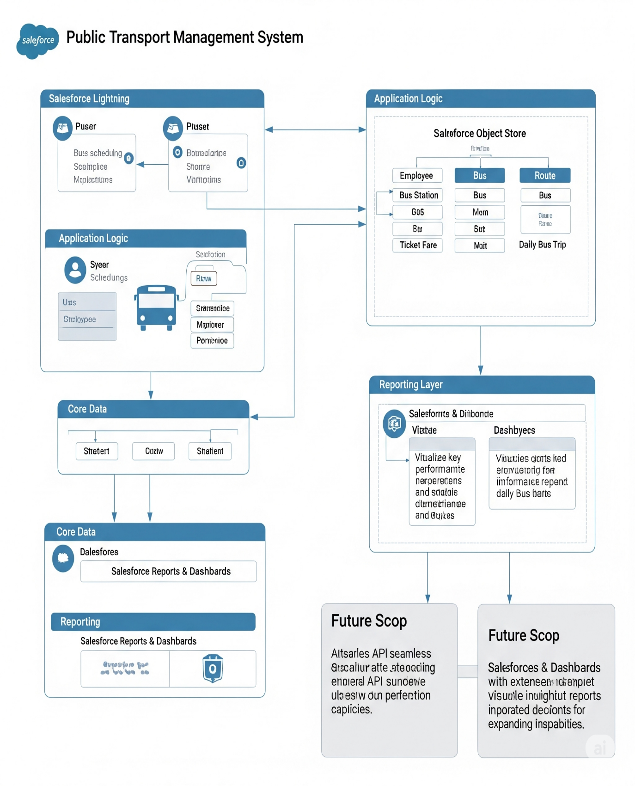

**Table 1: Components & Technologies**

| S.No | Component | Description | Technology |
| --- | --- | --- | --- |
| 1 | User Interface | Web-based interface on Salesforce Lightning for Transport Admins, Managers, Drivers, Conductors | Salesforce Lightning, HTML5, CSS3 |
| 2 | Application Logic | Automation and workflows for operational tasks (e.g., fare calculation, assignments) | Salesforce Flows |
| 3 | Database | Data storage and relationships for transport-specific custom and standard objects | Salesforce Object Store (Employee, Bus Station, Bus, Route, Ticket Fare, Daily Bus Trip Custom & Standard Objects) |
| 4 | Reporting | Dashboards and analytics for operational insights (e.g., passenger count, revenue) | Salesforce Reports & Dashboards |
| 5 | External API (Future) | Integration with public transport specific systems (e.g., ticketing, GPS tracking) | REST API (planned for future scope) |
| 6 | Infrastructure | Cloud hosting for the entire application | Salesforce Cloud Platform |

**Table 2: Application Characteristics**

| S.No | Characteristics | Description | Technology |
| --- | --- | --- | --- |
| 1 | Open-Source Frameworks | N/A (Salesforce is a proprietary platform) | N/A |
| 2 | Security Implementations | Role-based access for different transport roles, field-level security, Salesforce Shield (optional) | Salesforce IAM, Shield |
| 3 | Scalable Architecture | Multi-tenant cloud platform designed to support growing data volumes and user base for public transport operations | Salesforce Cloud Architecture |
| 4 | Availability | High availability ensured by robust Salesforce infrastructure and global data centers | Salesforce Platform HA features |
| 5 | Performance | Optimized with standard Salesforce best practices, efficient queries, and caching within reports | Salesforce Lightning, report optimizations |